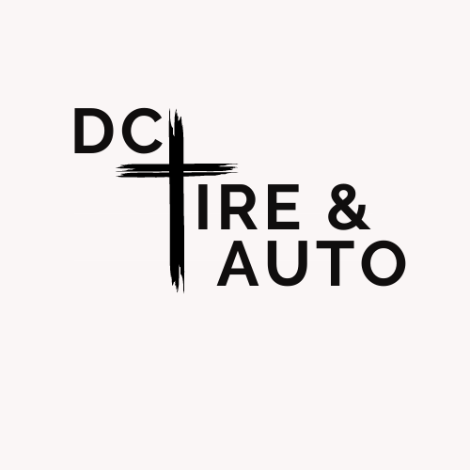
QUALITY SERVICE COUPON
5% Off Service Special
Repair or Service of $100 or more
(Maximum Discount $50)
EXPIRES 8/15/22
(One per person per month – This paper must be turned at the time of oil change)
804-561-2116
9001 Factory Street Amelia VA 23002

